Robust clipped correlation: USDCHF and EURGBP
Method 04 / daily log returns clipped at ±0.01, ±0.02, ±0.03 / Alpari D1 full available history

Study setup
Logical pair: USDCHF , EURGBP
Broker symbols: USDCHF_i , EURGBP_i
Snapshot: 2026-11-03_majors_alpari_D1
Timeframe: D1
Matched return window: 1999-01-06 to 2026-11-02 (UTC bar dates)
Matched return count n: 7182
Dropped unfinished last bar dated 2026-11-03 UTC after a tick-volume check against the prior complete day.
Clip bounds c in log-return units: 0.01, 0.02, 0.03 (about ±1%, ±2%, ±3% on the log scale). Headline c = 0.02.
Clipping caps a day's magnitude at ±c and keeps the row; it does not drop the day, so n is the same at every c.
Complete matched rows (Excel): USDCHF-EURGBP_Clipped_D1.xlsx
Complete matched rows (HTML table): USDCHF-EURGBP_Clipped_D1_data.html

Method carried forward
Each matched daily log return of close, ln(close_t / close_t-1), is clipped in the broker quote direction before Pearson correlation: x_tilde = min(c, max(-c, x)) and y_tilde = min(c, max(-c, y)), then rho_clip = Pearson(x_tilde, y_tilde) on the same rows as raw Pearson r. Quotes are not inverted. A day beyond ±c stays in the sample at the cap; n does not change. rho_clip is symmetric under swap of the two symbols. rho_clip = 0 means no straight-line link among the clipped values in this sample; it does not mean no link of any kind. The score is not a cause, not a lead, and not a trading signal. Daily rows are not independent draws, so the two-sided p-value and Fisher interval are reported and treated as secondary to rho_clip. Cap-hit counts (|log return| > c) flag how much of each leg was capped.

Raw Pearson on the same rows
Pearson r: -0.325886
Two-sided p-value: 2.5686e-177
Approximate 95% Fisher interval: [-0.346404, -0.305058]
This is the unclipped comparison required by the method. The headline score is rho_clip at c = 0.02 below.

Clipped results
n = 7182 at every c. Headline row is c = 0.02. Cap-hit count is the number of days with |log return| > c before clipping.
c | rho_clip | p | ci_low | ci_high | rho_minus_r | USDCHF_cap_hits | EURGBP_cap_hits | USDCHF_cap_share | EURGBP_cap_share
0.01 | -0.368458 | 8.3468393e-230 | -0.38827768 | -0.34829851 | -0.042571994 | 691 | 344 | 0.096213 | 0.047898
0.02 | -0.371226 | 1.6640259e-233 | -0.39099679 | -0.35111227 | -0.045339299 | 47 | 18 | 0.006544 | 0.002506
0.03 | -0.365015 | 2.9873859e-225 | -0.38489378 | -0.34479783 | -0.039128599 | 9 | 3 | 0.001253 | 0.000418

Conclusion
Over 7182 matched daily log-return rows for USDCHF and EURGBP (broker quote directions unchanged), headline robust clipped correlation at c=0.02 is -0.3712 (negative, weak straight-line association among clipped values in this sample). Approximate 95% Fisher interval on the clipped series: [-0.3910, -0.3511]. Same-sample raw Pearson r is -0.3259 (rho_clip minus r = -0.0453). Sensitivity across the fixed grid: c=0.01 same sign; c=0.02 same sign; c=0.03 same sign. Two-sided p under the usual independent bivariate-normal model is 1.664e-233; that model does not match linked daily FX returns, so treat p as secondary. This does not establish cause, lead-lag, or a lasting trading rule.

What to look at in this file next time
1) rho_clip at c = 0.02 versus raw Pearson r. 2) Whether c = 0.01 and c = 0.03 keep the same sign as 0.02. 3) Cap-hit counts before treating a large gap as settled. 4) The ±0.02 lines on the returns chart and the clip box on the scatter.

Charts
Daily closes

Daily log returns with +/- 0.02 clip lines
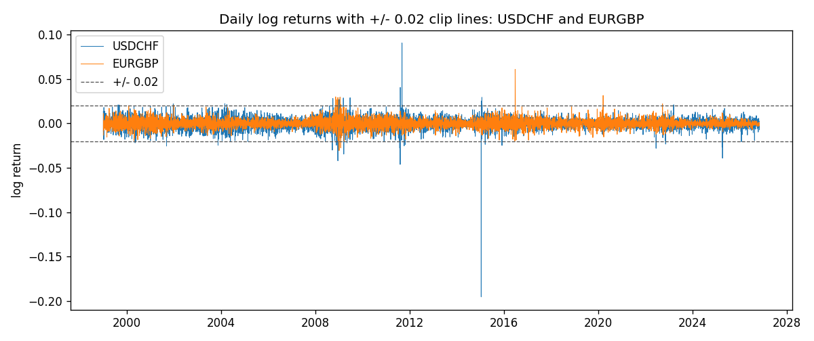
Log-return scatter with +/- 0.02 clip box
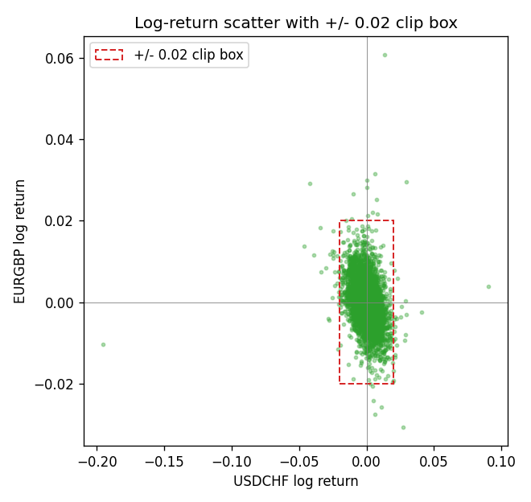

Data report
Every matched row that entered the clipped and raw correlations is stored in the sibling Excel workbook named USDCHF-EURGBP_Clipped_D1.xlsx. That file is the complete data archive for redrawing charts. Embedding all rows as a Word table is impractical at this length; the Word file holds the column list, column summaries, and the first and last 15 matched rows.
Columns: time, USDCHF_open, EURGBP_open, USDCHF_high, EURGBP_high, USDCHF_low, EURGBP_low, USDCHF_close, EURGBP_close, USDCHF_tick_volume, EURGBP_tick_volume, USDCHF_spread, EURGBP_spread, USDCHF_real_volume, EURGBP_real_volume, USDCHF_log_return, EURGBP_log_return, USDCHF_log_return_clip_0p01, EURGBP_log_return_clip_0p01, USDCHF_log_return_clip_0p02, EURGBP_log_return_clip_0p02, USDCHF_log_return_clip_0p03, EURGBP_log_return_clip_0p03
Column summaries (matched calculation rows)
column | count | mean | std | min | 25% | 50% | 75% | max
USDCHF_open | 7182 | 1.0972493 | 0.25210985 | 0.72022 | 0.9204925 | 0.989875 | 1.237175 | 1.8219
EURGBP_open | 7182 | 0.7869939 | 0.09664695 | 0.5734 | 0.6877 | 0.833905 | 0.865225 | 0.9769
USDCHF_high | 7182 | 1.1025378 | 0.25385182 | 0.73305 | 0.924695 | 0.99351 | 1.242175 | 1.8313
EURGBP_high | 7182 | 0.79007306 | 0.09702085 | 0.5789 | 0.6897 | 0.836955 | 0.8681 | 0.9799
USDCHF_low | 7182 | 1.092133 | 0.25052689 | 0.08565 | 0.9171825 | 0.986205 | 1.2312 | 1.8121
EURGBP_low | 7182 | 0.7842938 | 0.09646529 | 0.5682 | 0.685725 | 0.83166 | 0.86287 | 0.9661
USDCHF_close | 7182 | 1.09724 | 0.25200902 | 0.72025 | 0.9207375 | 0.98991 | 1.23715 | 1.8217
EURGBP_close | 7182 | 0.78703952 | 0.09664503 | 0.5735 | 0.687825 | 0.83398 | 0.865375 | 0.977
USDCHF_tick_volume | 7182 | 74362.695 | 113509.88 | 18 | 12814.25 | 40258.5 | 70446 | 858589
EURGBP_tick_volume | 7182 | 87145.49 | 145506.26 | 154 | 6593.75 | 44371 | 81432 | 1424684
USDCHF_spread | 7182 | 26.020746 | 24.692144 | 0 | 5 | 16 | 50 | 100
EURGBP_spread | 7182 | 21.320663 | 19.117614 | 0 | 4 | 13 | 40 | 50
USDCHF_real_volume | 7182 | 2.3303821e+10 | 8.915094e+10 | 0 | 0 | 0 | 0 | 1.9331921e+12
EURGBP_real_volume | 7182 | 2.7876168e+10 | 1.3522356e+11 | 0 | 0 | 0 | 0 | 3.5726265e+12
USDCHF_log_return | 7182 | -7.199e-05 | 0.00659004 | -0.19545699 | -0.00335239 | 7.626e-05 | 0.00331734 | 0.09051364
EURGBP_log_return | 7182 | 2.529e-05 | 0.00487429 | -0.03067367 | -0.00262165 | -0.00010006 | 0.00256425 | 0.06075387
USDCHF_log_return_clip_0p01 | 7182 | -2.325e-05 | 0.00514609 | -0.01 | -0.00335239 | 7.626e-05 | 0.00331734 | 0.01
EURGBP_log_return_clip_0p01 | 7182 | 2.57e-06 | 0.00435383 | -0.01 | -0.00262165 | -0.00010006 | 0.00256425 | 0.01
USDCHF_log_return_clip_0p02 | 7182 | -4.683e-05 | 0.00592482 | -0.02 | -0.00335239 | 7.626e-05 | 0.00331734 | 0.02
EURGBP_log_return_clip_0p02 | 7182 | 1.448e-05 | 0.00476105 | -0.02 | -0.00262165 | -0.00010006 | 0.00256425 | 0.02
USDCHF_log_return_clip_0p03 | 7182 | -5.243e-05 | 0.00605456 | -0.03 | -0.00335239 | 7.626e-05 | 0.00331734 | 0.03
EURGBP_log_return_clip_0p03 | 7182 | 2.09e-05 | 0.00483239 | -0.03 | -0.00262165 | -0.00010006 | 0.00256425 | 0.03
First 15 matched rows (selected columns)
time | USDCHF_close | EURGBP_close | USDCHF_log_return | EURGBP_log_return | USDCHF_log_return_clip_0p02 | EURGBP_log_return_clip_0p02
1999-01-06 | 1.3912 | 0.7019 | 0.013605652 | -0.013303338 | 0.013605652 | -0.013303338
1999-01-07 | 1.3782 | 0.7097 | -0.0093883841 | 0.011051402 | -0.0093883841 | 0.011051402
1999-01-08 | 1.3935 | 0.7062 | 0.011040268 | -0.004943862 | 0.011040268 | -0.004943862
1999-01-11 | 1.4009 | 0.7053 | 0.0052963193 | -0.0012752393 | 0.0052963193 | -0.0012752393
1999-01-12 | 1.3872 | 0.7077 | -0.0098275602 | 0.0033970309 | -0.0098275602 | 0.0033970309
1999-01-13 | 1.3621 | 0.708 | -0.018259701 | 0.00042381861 | -0.018259701 | 0.00042381861
1999-01-14 | 1.3588 | 0.7066 | -0.0024256692 | -0.0019793588 | -0.0024256692 | -0.0019793588
1999-01-15 | 1.3834 | 0.7012 | 0.01794228 | -0.0076715819 | 0.01794228 | -0.0076715819
1999-01-18 | 1.379 | 0.7017 | -0.0031856384 | 0.00071280921 | -0.0031856384 | 0.00071280921
1999-01-19 | 1.3789 | 0.7007 | -7.2518946e-05 | -0.0014261269 | -7.2518946e-05 | -0.0014261269
1999-01-20 | 1.3889 | 0.7021 | 0.0072259871 | 0.0019960086 | 0.0072259871 | 0.0019960086
1999-01-21 | 1.3836 | 0.7016 | -0.0038232689 | -0.00071240297 | -0.0038232689 | -0.00071240297
1999-01-22 | 1.3834 | 0.7004 | -0.0001445609 | -0.0017118406 | -0.0001445609 | -0.0017118406
1999-01-25 | 1.3868 | 0.6966 | 0.0024546976 | -0.0054402425 | 0.0024546976 | -0.0054402425
1999-01-26 | 1.3897 | 0.6962 | 0.0020889617 | -0.00057438255 | 0.0020889617 | -0.00057438255
Last 15 matched rows (selected columns)
time | USDCHF_close | EURGBP_close | USDCHF_log_return | EURGBP_log_return | USDCHF_log_return_clip_0p02 | EURGBP_log_return_clip_0p02
2026-10-13 | 0.83244 | 0.84458 | -0.0024955621 | 0.00020130374 | -0.0024955621 | 0.00020130374
2026-10-14 | 0.83489 | 0.84553 | 0.0029388325 | 0.0011241873 | 0.0029388325 | 0.0011241873
2026-10-15 | 0.82676 | 0.84479 | -0.0097855323 | -0.00087557391 | -0.0097855323 | -0.00087557391
2026-10-16 | 0.82377 | 0.84307 | -0.0036230826 | -0.0020380844 | -0.0036230826 | -0.0020380844
2026-10-19 | 0.82677 | 0.84259 | 0.0036351779 | -0.00056950988 | 0.0036351779 | -0.00056950988
2026-10-20 | 0.8246 | 0.83957 | -0.0026281224 | -0.0035906254 | -0.0026281224 | -0.0035906254
2026-10-21 | 0.82427 | 0.83839 | -0.00040027413 | -0.00140647 | -0.00040027413 | -0.00140647
2026-10-22 | 0.82032 | 0.83682 | -0.0048036381 | -0.0018743924 | -0.0048036381 | -0.0018743924
2026-10-23 | 0.82497 | 0.83751 | 0.005652514 | 0.00082421033 | 0.005652514 | 0.00082421033
2026-10-26 | 0.82649 | 0.83762 | 0.0018407959 | 0.00013133309 | 0.0018407959 | 0.00013133309
2026-10-27 | 0.82865 | 0.83595 | 0.0026100526 | -0.0019957343 | 0.0026100526 | -0.0019957343
2026-10-28 | 0.82781 | 0.83651 | -0.0010142111 | 0.00066967224 | -0.0010142111 | 0.00066967224
2026-10-29 | 0.82379 | 0.83553 | -0.0048680164 | -0.0011722209 | -0.0048680164 | -0.0011722209
2026-10-30 | 0.82438 | 0.83351 | 0.00071594559 | -0.0024205543 | 0.00071594559 | -0.0024205543
2026-11-02 | 0.81851 | 0.83426 | -0.0071459744 | 0.00089940465 | -0.0071459744 | 0.00089940465

